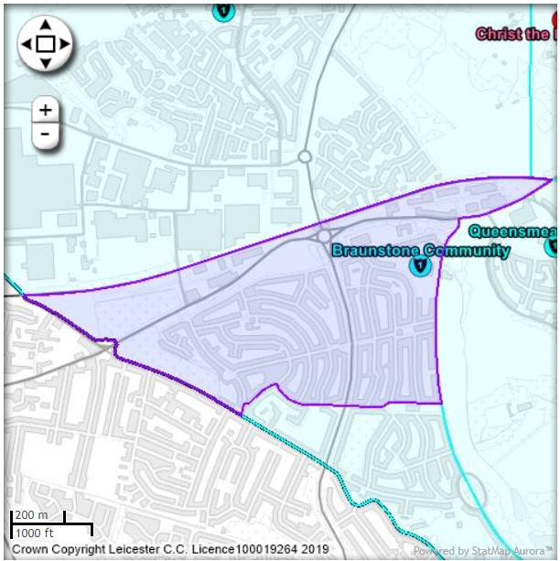
Accessed Via Find schools in your catchment area (leicester.gov.uk)

